**The Process of Digestion through Chicken Breast**

**Introduction**

The digestive system is made up of a network of organs and tissues that take in foods and liquids and break them down into nutrients that the body can use for energy, growth, and repair before turning it into waste. In this report, the process of digestion in the human body will be described using the chicken breast as an example. The chicken breast is a cut of meat taken from the pectoral muscle of the chicken. They are a great source of protein and is low in fat. This combination of lean protein and vitamins such as vitamin B, D, iron, and zinc makes it a very popular cut of chicken around the world. **(*All about Chicken Breast: Chicken Breast Nutrition and Chicken Breast Recipes - 2023 - MasterClass*, 2020) (*NCI Dictionary of Cancer Terms*, 2023).**

**Mouth and Oesophagus**

The process of digestion first starts with the mouth and oesophagus. When a cut of chicken breast is taken into the mouth, the salivary glands which produce saliva moisten the food and their enzymes can break down starches or fats that may be contained in the chicken. The teeth will chew and mix the combination of chicken breast and saliva into a bolus or a small ball of food so it can go down the oesophagus and gets processed easier. Upon swallowing the food, a flap of cartilage called the epiglottis, located between the tongue and the larynx will direct the food down the oesophagus instead of the windpipes. The oesophagus will then direct the chicken breast into the stomach. **(and, 2023).**

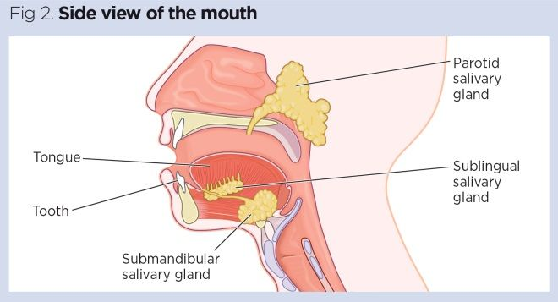

**(*Gastrointestinal Tract 1: The Mouth and Oesophagus | Nursing Times*, 2019)**

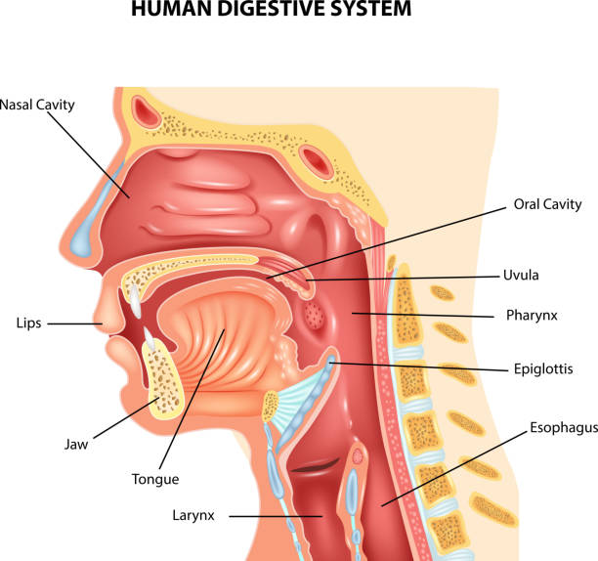

**(2016)**

**Stomach**

The stomach acid and enzymes used to aid in digestion and break down foods and liquids are all contained within the stomach. The mechanical digestion starts as the bolus containing the chicken breast will be grinded and mixed into even smaller pieces by the stomach muscle to prepare it for chemical digestion. The three main types of enzymes called pepsin, trypsin, and chymotrypsin are secreted from the stomach and pancreas to work together and aid in protein digestion. Proteins from the chicken breast will be broken down into polypeptides by the 3 enzymes before turning them into amino acids. The pepsin enzyme begins to break down the peptide bonds holding protein together before it passes off to the smaller intestines to continue the chemical digestion process. **(*22.12B: Chemical Digestion of Carbohydrates, Proteins, Lipids, and Nucleic Acids*, 2018).**

**Small Intestines (Breakdown)**

The small intestines are the main organs that extract all of the nutrients, vitamins, carbohydrates, proteins, and minerals from food and liquid. When the tiny pieces of chicken breast travel down to the small intestines, the pancreas will excrete enzymes called chymotrypsin and trypsin. These two enzymes will finally break down the small pieces of proteins form the chicken breast into amino acids and dipeptides. Bile, a thick liquid produced by the gallbladder helps to carry away waste throughout the entire digestive system and also breaks down fat. The walls lining the small intestines will then absorb all the nutrients, and protein into the bloodstream for use within the body. **(*5.4: Protein Digestion, Absorption and Metabolism*, 2017) (*Biliary System Anatomy and Functions*, 2019).**

**Small Intestine (Absorption)**

After breaking down proteins, amino acids and dipeptides, it is absorbed in the small intestine and released into the bloodstream. Covering the lining of the small intestines, are tiny finger-like projections called villi. They increase the surface area of the small intestines and allow for a more effective absorption of nutrients into the bloodstream. On the villi, there are hair-like projections called microvilli which also help to increase the surface area of the small intestines. The absorption of nutrients involves active and passive transport to pass on specific nutrients into the bloodstream. Nutrients that are transported actively and needs energy include amino acids and glucose. Passive transport requires no energy and transports nutrients such as water. Inside the villi, a network of capillaries takes up the absorbed nutrients before delivering them to arteries and veins for use in the body. **(Roberts, 2012) (Admin, 2018) (*Small Intestine - Digestion - Absorption - TeachMePhysiology*, 2023) (*Differences in Small & Large Intestines | Children’s Pittsburgh*, 2023).**

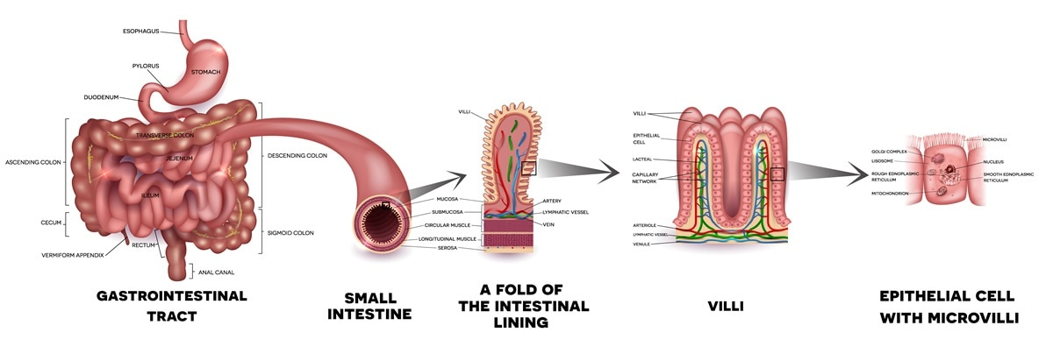

**(*26,405 Small Intestine Images, Stock Photos & Vectors | Shutterstock*, 2023)**

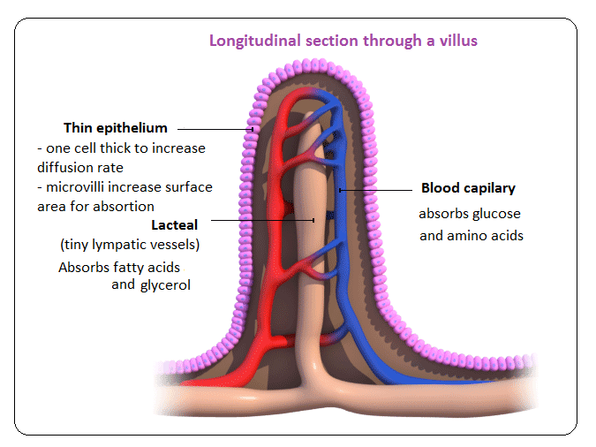

**(in, 2013)**

**Material Breakdown and use**

The nutrients derived from the chicken breast will now be put to use in the body. Protein broken down into amino acids are able to help synthesize new proteins and grow and repair body tissues. The fatty acids coming from the fat of the chicken can be used for energy production or can be stored as triglycerides in the adipose tissue. Carbohydrates which are broken down into glucose is the main energy source for the body. Glycogen, the result of broken-down carbohydrates, is the stored form of glucose and is stored inside the liver and muscles. Glycogen can turn into glucose if the body isn’t getting enough glucose from food. Vitamins and minerals from the chicken can help in bodily functions such as fighting infection, healing wounds, making the bones stronger, and regulating hormones. **(Health, 2013) (*Definition: Glycogen (for Teens) - Nemours KidsHealth*, 2023) (*Energy Storage*, 2015) (*Amino Acids, Evolution | Learn Science at Scitable*, 2014) (Miller, 2020) (Chicken, 2020).**

**Large Intestine**

After the small intestine, remaining pieces of the chicken breast goes here. The large intestine’s main function is to absorb water, minerals and vitamins, and getting rid of other waste products left over. The colon, which is the longest part of the large intestine absorbs water and some minerals and vitamins that had not been absorbed by the small intestine. The colon also produces vitamins called vitamin K and variants of vitamin B to be absorbed into the bloodstream. The colon also houses many types of bacteria to aid in the breakdown of materials coming through the large intestine. Bacteria in the colon helps with creating vitamins and protecting the gut from harmful diseases or infections as part of the immune system. The bacteria in the colon can also help breakdown fibres and carbohydrates that are difficult to digest. Methane and hydrogen gasses are created by the bacteria in the large intestine which will eventually leave the body as flatulence. **(*The Truth about Gas*, 2023) (Azzouz & Sharma, 2022)** **(*NCI Dictionary of Cancer Terms*, 2023).**

**Elimination and Faeces**

After the large intestine, everything else that has not been absorbed will be eliminated and stored as faeces. Compressed waste or faeces is sent from the large intestine into the rectum, where the waste will be kept until they eventually leave the body through the anus, an opening at the end of the rectum. Faeces is made up of remaining food that couldn’t be digested or absorbed, dead epithelial cells, bile, and cellular waste. The faeces leaves the body in the form of defecation. **(“Feces | Biology | Britannica,” 2023)** **(Body, 2023).**

**References**

1. *All About Chicken Breast: Chicken Breast Nutrition and Chicken Breast Recipes - 2023 - MasterClass*. (2020). MasterClass. <https://www.masterclass.com/articles/all-about-chicken-breast-chicken-breast-nutrition-and-chicken-breast-recipes>
2. *NCI Dictionary of Cancer Terms*. (2023). National Cancer Institute; Cancer.gov. <https://www.cancer.gov/publications/dictionaries/cancer-terms/def/digestive-system>
3. and, D. (2023, May 5). *Your Digestive System & How it Works*. National Institute of Diabetes and Digestive and Kidney Diseases; NIDDK - National Institute of Diabetes and Digestive and Kidney Diseases. <https://www.niddk.nih.gov/health-information/digestive-diseases/digestive-system-how-it-works>
4. (2016). Istockphoto.com. <https://www.istockphoto.com/illustrations/epiglottis>
5. *Gastrointestinal tract 1: the mouth and oesophagus | Nursing Times*. (2019, May 28). Nursing Times. <https://www.nursingtimes.net/clinical-archive/gastroenterology/gastrointestinal-tract-1-the-mouth-and-oesophagus-28-05-2019/>
6. *22.12B: Chemical Digestion of Carbohydrates, Proteins, Lipids, and Nucleic Acids*. (2018, July 22). Medicine LibreTexts. <https://med.libretexts.org/Bookshelves/Anatomy_and_Physiology/Anatomy_and_Physiology_(Boundless)/22%3A_Digestive_System/22.12%3A_Chemical_Digestion/22.12B%3A_Chemical_Digestion_of_Carbohydrates_Proteins_Lipids_and_Nucleic_Acids#:~:text=Protein%20digestion%20occurs%20in%20the,by%20salivary%20and%20pancreatic%20amylase>.
7. *5.4: Protein Digestion, Absorption and Metabolism*. (2017, June 14). Medicine LibreTexts. <https://med.libretexts.org/Courses/American_Public_University/APUS%3A_An_Introduction_to_Nutrition_(Byerley)/APUS%3A_An_Introduction_to_Nutrition_1st_Edition/05%3A_Proteins/5.04%3A_Protein_Digestion_Absorption_and_Metabolism#:~:text=Chemical%20digestion%20of%20protein%20begins,acids%20to%20make%20more%20proteins>.
8. *26,405 Small Intestine Images, Stock Photos & Vectors | Shutterstock*. (2023). Shutterstock. <https://www.shutterstock.com/search/small-intestine>
9. Roberts, S. (2012, November 5). *The Ways in Which Nutrients Are Absorbed*. Weekand.com; Weekand. <https://www.weekand.com/healthy-living/article/ways-nutrients-absorbed-18024611.php>
10. Admin. (2018, June 24). *Difference Between Active Transport and Passive Transport*. BYJUS; BYJU’S. <https://byjus.com/biology/difference-between-active-and-passive-transport/>
11. *Small Intestine - Digestion - Absorption - TeachMePhysiology*. (2023, May). TeachMePhysiology. <https://teachmephysiology.com/gastrointestinal-system/small-intestine/digestion-and-absorption/>
12. *Differences in Small & Large Intestines | Children’s Pittsburgh*. (2023). Children’s Hospital of Pittsburgh. <https://www.chp.edu/our-services/transplant/intestine/education/about-small-large-intestines#:~:text=The%20small%20intestine%20carries%20out,and%20pancreas%20to%20do%20this>.
13. Health. (2013). *Vitamins and minerals*. Vic.gov.au. <https://www.betterhealth.vic.gov.au/health/healthyliving/Vitamins-and-minerals>
14. *Definition: Glycogen (for Teens) - Nemours KidsHealth*. (2023). Kidshealth.org. <https://kidshealth.org/en/teens/glycogen.html#:~:text=This%20stored%20form%20of%20glucose,as%20fuel%20for%20the%20cells>.
15. *Energy Storage*. (2015). Cliffsnotes.com. <https://www.cliffsnotes.com/study-guides/biology/biochemistry-ii/lipid-biosynthesis/energy-storage>
16. *Amino Acids, Evolution | Learn Science at Scitable*. (2014). Nature.com. <https://www.nature.com/scitable/topicpage/an-evolutionary-perspective-on-amino-acids-14568445/#:~:text=Their%20primary%20function%20is%20to,are%20derived%20from%20amino%20acids>.
17. Miller, C. (2020, September). *5.7 Protein Synthesis*. Pressbooks.tru.ca; Thompson Rivers University. <https://humanbiology.pressbooks.tru.ca/chapter/5-6-protein-synthesis/#:~:text=Protein%20synthesis%20is%20the%20process,to%20mRNA%20in%20the%20nucleus>.
18. Chicken. (2020, May 23). *What’s so great about chicken? - ACMF*. ACMF. <https://www.chicken.org.au/whats-so-great-about-chicken/#:~:text=It%20contains%20many%20nutrients%20required,and%20minerals%20selenium%20and%20zinc>.
19. in. (2013). *Villi in the Small Intestine - Biology | Socratic*. Socratic.org. <https://socratic.org/biology/input-and-output/villi-in-the-small-intestine>
20. *The Truth About Gas*. (2023). Unitypoint.org. <https://www.unitypoint.org/news-and-articles/the-truth-about-gas>
21. Azzouz, L. L., & Sharma, S. (2022, August). *Physiology, Large Intestine*. Nih.gov; StatPearls Publishing. <https://www.ncbi.nlm.nih.gov/books/NBK507857/#:~:text=The%20colon%20houses%20trillions%20of,then%20absorbed%20into%20the%20blood>.
22. *NCI Dictionary of Cancer Terms*. (2023). National Cancer Institute; Cancer.gov. <https://www.cancer.gov/publications/dictionaries/cancer-terms/def/colon>
23. Feces | biology | Britannica. (2023). In *Encyclopædia Britannica*. <https://www.britannica.com/science/feces>
24. Body, V. (2023). *Large Intestine*. Visiblebody.com. <https://www.visiblebody.com/learn/digestive/digestive-absorption-and-elimination#:~:text=Defecation%20Eliminates%20Waste%20From%20the,of%20the%20external%20anal%20sphincter>.

‌